SIMATS ENGINEERING
ASSESSMENT TOOL 1 – Medium (Scenario Based Assessment)
COURSE CODE: CSA09 COURSE NAME: Programming in Java
COURSE OUTCOME COVERED
CO2: Implement Collection Framework interfaces such as List, ArrayList, Set, Map, HashTable, and HashMap using iterators and generics to store, retrieve, and process groups of objects in web applications.(BL3,BL4)

QUESTIONS: 5 Total Marks: 100
ANNEXURE A
Scenario Based Assessment
Code of Conduct:

IK. Amrutha Sandhya(192524270) (Name / Reg No) certify that this submission is my original work and that I have adhered to the guidelines specified for this assessment.
I understand that any violation of academic integrity rules will result in disciplinary action.

Signature of the student:
Amrutha
RUBRICS FOR CALCULATION:

Criteria | Level 4 – Exemplary | Level 3 – Proficient | Level 2 – Developing | Level 1 – Beginning
Problem Understanding & Context Analysis
Application of Concepts
Analytical & Decision-Making Skills
Solution Design & Approach
Clarity, Justification & Presentation

ANNEXURE
Scenario Based Assessment
Q1: Student Registration System
Suppose that a university system stores student data, where each student must be unique and can enroll in multiple courses.
(a) Enumerate three Collection interfaces suitable for this system.
(b) Design a Collection structure (diagram/representation) to store students and their enrolled courses.
(c) Write a Java program using HashSet and HashMap with Generics to:
• Add students
• Map students to courses
• Display data using Iterator
(a) Collection Interfaces
- Set – Stores unique students.
- List – Stores courses for each student.
- Map – Maps students to their enrolled courses.
(b) Collection Structure Diagram
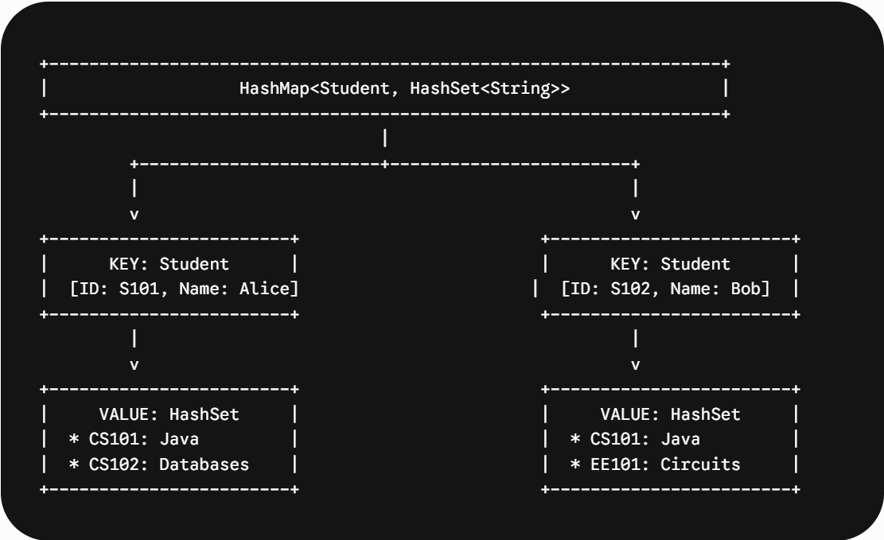

Explanation:
- HashSet stores unique student names.
- HashMap maps each student to a list of enrolled courses.
(c) Java Program
import java.util.*;
public class StudentRegistration {
public static void main(String[] args) {
HashSet<String> students = new HashSet<>();
HashMap<String, ArrayList<String>> courses = new HashMap<>();
students.add("Amrutha");
students.add("Rahul");
courses.put("Amrutha", new ArrayList<>(Arrays.asList("Java","DBMS")));
courses.put("Rahul", new ArrayList<>(Arrays.asList("Python","AI")));
Iterator<String> it = students.iterator();
while(it.hasNext()){
String s = it.next();
System.out.println(s + " : " + courses.get(s));
}
}
}
Q2: E-Commerce Cart System
Suppose that an online shopping system maintains a cart where products are added, removed, and displayed in order.
(a) List three Collection classes applicable for cart management.
(b) Represent how cart items are stored using a List-based structure.
(c) Write a Java program using ArrayList and Iterator to:
• Add items
• Remove an item
• Display all items
(a) Collection Classes
- ArrayList
- LinkedList
- Vector
(b) List-Based Structure Diagram
ArrayList (Shopping Cart)
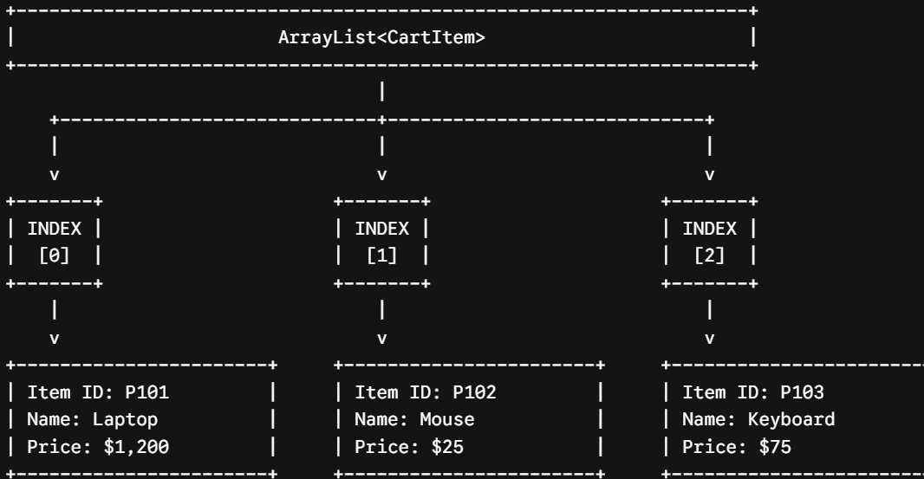

Explanation:
The cart maintains insertion order, making ArrayList suitable.
(c) Java Program
import java.util.*;
public class CartSystem {
public static void main(String[] args) {
ArrayList<String> cart = new ArrayList<>();
cart.add("Laptop");
cart.add("Mouse");
cart.add("Keyboard");
cart.remove("Mouse");
Iterator<String> it = cart.iterator();
while(it.hasNext()){
System.out.println(it.next());
}
}
}
Q3: Library Management System
Suppose that a library stores books with unique ISBN numbers and needs fast retrieval.
(a) Name three Map implementations in Java.
(b) Design a schema-like representation using Map for storing ISBN and book details.
(c) Write a Java program using HashMap to:
• Insert book details
• Retrieve a book
• Display all books

(a) Map Implementations
- HashMap
- TreeMap
- LinkedHashMap
(b) Map Structure Diagram
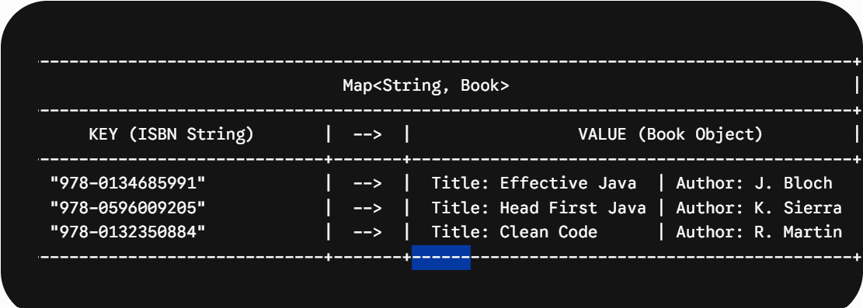

Explanation:
ISBN acts as the key, and book details are stored as the value.
(c) Java Program
import java.util.*;
public class Library {
public static void main(String[] args) {
HashMap<Integer,String> books = new HashMap<>();
books.put(101,"Java");
books.put(102,"Python");
books.put(103,"DBMS");
System.out.println(books.get(102));
for(Map.Entry<Integer,String> e : books.entrySet()){
System.out.println(e.getKey()+" : "+e.getValue());
}
}
}
Q4: Employee Data Processing
Suppose that a company processes employee records and filters employees based on salary.
(a) List three advantages of Generics in Collections.
(b) Represent how employee data is stored using List with Generics.
(c) Write a Java program using Iterator to:
• Store employee objects
• Display employees with salary > 50,000
(a) Advantages of Generics
- Type Safety
- No Explicit Type Casting
- Code Reusability

(b) List Structure Diagram
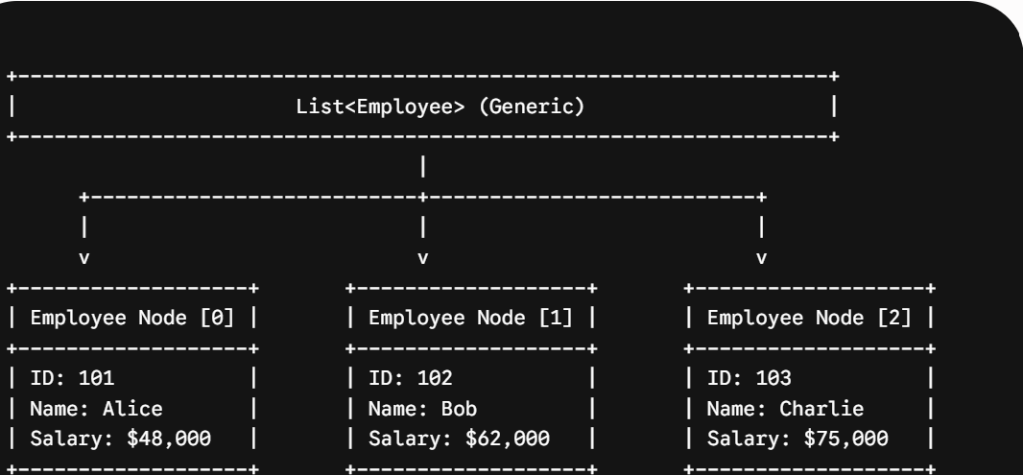
(c) Java Program
import java.util.*;
class Employee{
int id;
String name;
double salary;
Employee(int id,String name,double salary){
this.id=id;
this.name=name;
this.salary=salary;
}
}
public class EmployeeData{
public static void main(String args[]){
ArrayList<Employee> list=new ArrayList<>();
list.add(new Employee(101,"Ravi",45000));
list.add(new Employee(102,"Anu",60000));
list.add(new Employee(103,"Kiran",70000));
Iterator<Employee> it=list.iterator();
while(it.hasNext()){
Employee e=it.next();
if(e.salary>50000){
System.out.println(e.id+" "+e.name+" "+e.salary);
}
}
}
}

Q5: Online Voting System
Suppose that an online voting system ensures one vote per user and counts votes efficiently.
(a) Identify three suitable Collection types for this system.
(b) Design a structure using Set and Map for voters and vote counting.
(c) Write a Java program using HashSet and HashMap to:
• Record votes
• Prevent duplicate voting
• Display results
Below is a neat exam-writing format with simple diagrams that you can draw easily in your answer sheet.
(a) Suitable Collection Types
- HashSet
- HashMap
- TreeMap
(b) Set and Map Structure Diagram
HashSet (Unique Voters)
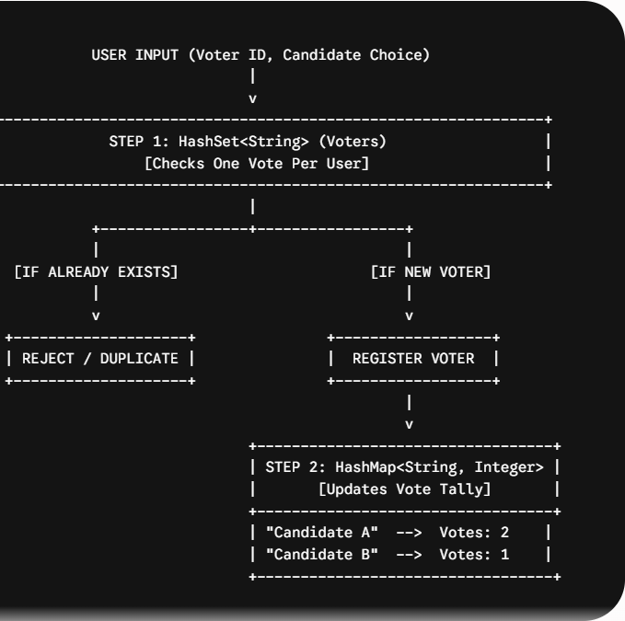
(c) Java Program
import java.util.*;
public class VotingSystem{
public static void main(String args[]){
HashSet<String> voters=new HashSet<>();
HashMap<String,Integer> votes=new HashMap<>();
votes.put("A",0);
votes.put("B",0);
String voter="V1";
String candidate="A";
if(voters.add(voter)){
votes.put(candidate,votes.get(candidate)+1);
}
else{
System.out.println("Duplicate Vote");
}
for(Map.Entry<String,Integer> e:votes.entrySet()){
System.out.println(e.getKey()+" = "+e.getValue());
}
}
}

